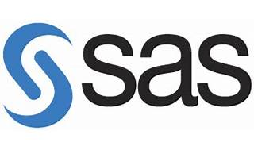

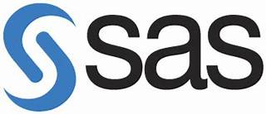

Explore

**SAS (Statistical Analysis System)** is a comprehensive statistical software suite developed by SAS Institute. It serves various purposes, including data management, advanced analytics, multivariate analysis, business intelligence, criminal investigation, and predictive analytics. [SAS employs artificial intelligence, machine learning, deep learning, and generative AI to manage and model data1](https://en.wikipedia.org/wiki/SAS_%28software%29).

Here are **five free reference links** where you can learn SAS programming:

1. [**SAS Tutorial for Beginners**](https://www.guru99.com/sas-tutorial.html): This tutorial covers the basics of SAS, its features, architecture, and programming language with simple examples[2](https://www.guru99.com/sas-tutorial.html).
2. [**Introduction to SAS Programming**](https://www.geeksforgeeks.org/introduction-to-sas-programming/): Learn about SAS’s usefulness in advanced analytics, multivariate analyses, business intelligence, data management, and predictive analytics[3](https://www.geeksforgeeks.org/introduction-to-sas-programming/).
3. [**Free Online Training by SAS**](https://www.sas.com/en_us/training/offers/free-training.html): Explore free courses, trials, and resources developed by top SAS trainers. [Topics include SAS programming, statistics, data literacy, and more](https://en.wikipedia.org/wiki/SAS_%28software%29)[4](https://www.sas.com/en_us/training/offers/free-training.html).
4. [**Learn SAS Code**](https://learnsascode.com/): Dive into in-depth SAS knowledge, tutorials, and practical examples for beginners to advanced users[5](https://learnsascode.com/).
5. [**A Complete SAS Tutorial for Beginners**](https://sascrunch.com/sas-tutorial/): Access over 90 lessons, practice exercises, and real-world case studies to build your SAS skills[6](https://sascrunch.com/sas-tutorial/).

Happy learning! 📊📚